Step 1:

Init K means and variances

Step 2:

Find mu(z_nk)

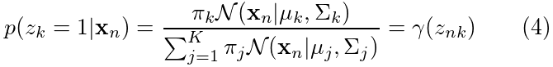

Step 3:

Find new values for

Pi_k



Mean_k and var_k

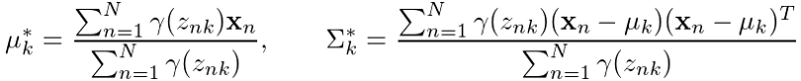

Return to Step 2